SOP: CEC Call Logging Process

Objective
Customer Contact Verification During Call Logging
To ensure accurate identification, verification, and secure handling of customer details during call logging instances.

Scope
This SOP applies to all CEC L1s responsible for logging customer inbound calls from Lenovo customers.

Verification Process:
When a customer contacts Lenovo, the CEC must first determine if the customer
is registered or non-registered, i.e., whether their details are available in the MSD.

Scenario 1: No Contact Registered
- Action:
  - Create a new contact in the MSD using the details provided by the caller.
  - Proceed with logging the case and offer support as per the standard process.

Scenario 2: Contact/Case Already Registered
- Caller Number Matches Registered Contact (Primary or Alternate):
  - Proceed with logging the case and provide support as per warranty guidelines
- Caller Number Does NOT Match Registered Contact:
  - Create a case and tag it as: #MP/No Power/No-Match
  - Provide the caller with two verification options:
    - Call back from the registered contact number, or
    - Send a two-way email:

      - You initiate an email to the registered customer email ID.
      - The customer must respond from the same registered email ID.
  - If the customer successfully verifies via either method, proceed with support.
  - Important: Do not disclose the registered contact number or email ID to the caller.
- If the customer is unable to verify:
  - Deny support due to failed verification.
  - In case of dispute, escalate the case to the Operations Manager (OM).

Scenario 3: Contact Exists but No Case Logged (Backend Integration Cases)
- If the system shows a contact exists (via backend integration) but no case is logged:
  - Follow the same process as outlined in Scenario 2.
  - Ensure verification steps are completed before proceeding.

Escalation Matrix:
- Customer Disputes or any unclear scenario should be escalated to the Operations Manager for resolution.
- The OM will review the case logs and determine the appropriate course of action. All such reviews must be documented in MSD and MS Form and retained for audit purposes.
- Each dispute/grievance/scenario will be reviewed on a case-by-case basis. OM will provide/suggest resolution based on available records, verification attempts, and applicable Lenovo guidelines and policies (if any).
- In case of any exceptional situation where the OM is unable to suggest a
proper resolution to the dispute or any unclear scenario, the OM will escalate the case to Customer Care Team
- Customer will be informed of the outcome within 2 working days.
- This protocol ensures that exceptional cases are handled fairly and transparently. The resolutions provided by the OM will be subject to periodical review to determine if the resolutions have been provided objectively and fairly, with a view to further advise the OM on any corrective action to be taken.

2-Way Email Draft:
Subject: Verification Required to Proceed with Call Logging Dear Customer,
Thank you for reaching out to us.
We note that you have approached us through a contact number that is not registered with Lenovo. To proceed with logging your service request, we kindly ask you to confirm
whether you intended to contact us regarding your system. If yes, please choose one of the following verification options:

Call us back from your registered contact number, or
- Respond to this email with an acknowledgment from your registered email ID.
This verification step is essential to ensure the security and accuracy of your request. Once verified, we will proceed with the call logging process. Any personal data shared by you will be used only for verification and support purposes, in accordance with Lenovo’s Privacy
Policy.
Thank you for your cooperation. Best regards,

Call Script:
Dear Customer, we see that your contact is registered, but you're calling from a different number.
For verification, please either call us back from your registered contact number or respond to the email which we'll send to your registered email ID so we can proceed with your
request.

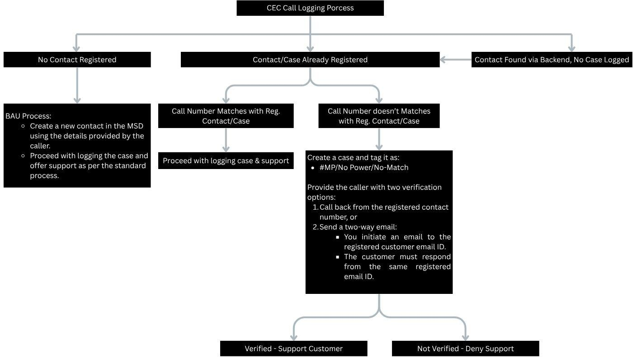

Data Protection & Access Control
The Lenovo Privacy Policy will apply to the customer data/information shared as part of
the process and any access and processing will be done in line with the protocols and steps provided in Lenovo’s Privacy Policy.

